

Prepared By:

Raneen Forsan

The National ICT Up skilling program – PHP section

Al-Hussain Technical University

Prepared for:

Mr. Salameh Yasien

MS. Zien Sadedin

Mr. Abdullah Shanaah

April 14, 2021

**DEDICATIONS**

I would like to take this opportunity to express my heartfelt gratitude to all those who helped them to make our work a success. First and foremost I would like to thank our work and contribute our best to it so that it has turned out to be a successful venue we express our heart full thanks to for valuable guidance, technical and moral support given to our throughout the entire project of dissertation work . we express our sincere and whole hearted thanks, to our Supervisor esteemed ***Eng.Salameh Yassien*** , for his regular advice, magnitude of dynamic and un tiresome guidance, suggestion and encouragement throughout the course.

# Abstract

An ecommerce website (Atomkit) is a website that deals specifically with customers(buyer) and vendors (seller). This web site which allow for buyer to buy from a lot of categories such as , Woman clothes, elegant bags, men shoes, men clothes, woman shoes, Accessories, Furniture, electronics, flats, vehicles, toys, phones . This website will reduce a lot of effort and cost for buyer and seller. Vendor doesn't need to real place to show their products. They can use Atomkit website as a small shop.

Table of Contents

Abstract 2

1 Introduction 4

2 Background 5

3 Methodology 8

4 Sequence Diagram 10

5 use case 13

5 Er Diagram 16

5 Class Diagram 19

6 Site map 20

7 Admin login 21

• Admin panel 22

• Admin panel on light mood 23

• Vendor login 24

• Vendor panel 25

• product 27

• post and carts 27

• post and carts 29

• Result and discussion 29

• Refrences 29

# Introduction

Atomkit Website : is a huge ecommerce website allow for multi customer to buy and sell from website . Atomkit contains from three users, the first user is Admin who can control all system and the second user is customer who can buy from website , the last one is vendor who can sell qualified goods on website . Atomkit website allow for vendors to sell category like Woman clothes, elegant bags, men shoes, men clothes, woman shoes, Accessories, Furniture, electronics, flats, vehicles, toys, phones. Atomkit website is a huge website. This document provides step-by-step instructions facilitate the using of a **Atomkit** website. This guide also provides detailed information for each users of how can sign in and log to system.

1. **Statement of the Problem**

Atomkit website is a huge ecommerce website which reduce effort and time for customer they can buy anything you want with half of price . For vendors they can sells from a lot of categories at any time. Everything is controlled and managed by admin.

1. **Significance of the project**

For customers :

Atomkit websites are very convenient to purchase products and services online. The process is often very quick as the customers can place orders in a relatively short period of time, without having to leave their homes or offices. Moreover, customers can purchase from Atomkit without having to physically move around. They will also have the opportunity to purchase products and service 24/7 comfortably and conveniently. Atomkit Allowing customers to shop for the comfort and convenience of their own homes at any time .Atomkit care to keep consumers happy and constantly change to adapt to their strategies according to their lifestyle and technological changes.

For vendors :

About 80% of users prefer accessing a store via a mobile app over a mobile site. Consumers are free to choose from the wide range of offerings according to their needs and demands. It’s a lot more convenient to buy everything from one place, rather than moving from store to store to fulfill different requirements. Which make the sales of customer increased.

# Background

During the past two decades, the internet has become an accepted way to purchase products and services. Buying and selling online are no exception. Besides its benefits, several customer are heading to the purchase of clothes, cars, accessories, shoes , toys . Although thousands of internet ecommerce websites are spreader but not all of these website are trusted , Atomkit website is secure, trusted and sell half of price of other ecommerce website.

1. **Requirement**

Any successful system should has functional and nonfunctional requirement . I will illustrate the functional requirement for each user:

* For vendor

1. Vendor can log into Atomkit website after sign in. If they haven't account, they should sign into system to benefit from system services.
2. Vendor can getting report about number of product that he uploaded, total of sales and number of customer that deal with ,orders also.
3. Vendor can view order and he/she can reject order or accept it. After order delivered, he/she can click on done button.
4. Vendor can write a post to publish it in a public website and he can edited, delete it.

* For Admin:

1. Admin can log into system to benefit from feature by enter password and email.
2. Admin can know about the number of product that downloaded by vendors , about customer number, total sales, number of vendors, number of orders, number of categories.
3. Admin can check of messages from customer or vendors.
4. Admin can check of orders
5. Admin can check of post request to approve it and uploaded it on public website
6. Admin can add another admins.
7. Admin can manage category of website(Add, delete, update it).
8. Admin can accept vendor request to join in website or reject.
9. Admin can block customer .
10. Admin can block vendor.
11. Admin can know information about vendor before accept or reject him/her from vendor profile such as name of company, mobile, license of company, type of category that he want to publish.
12. Admin can block product if it isn’t on a high quality.
13. Admin can block post.

For customer:

1. Customer can log into system to view order . If he/she hasn't a count she/he should make account.
2. Customer can view cart without log in to system .
3. Customer should log into system to ensure his/her order by click on send order.

**Non functional requirement**

Atomkit system should be secure customer shouldn’t know information about other customer, vendor shouldn’t know about other information vendor. Admin panel should be very secure , he will control for whole system. Atomkit should be usable from customer , every instruction is clear on website. Atomkit should be fast and with high performance.

1. **Programming language that used in system.**

**HTML** :(Hypertext Markup Language) is the code that is **used** to structure a web page and its content. For example, content could be structured within a set of paragraphs, a list of bulleted points, or using images and data tables.

**CSS**:is the acronym of “Cascading Style Sheets”. **CSS** is a computer language for laying out and structuring web pages (HTML or XML).

**CSS3**: Cascading Style Sheets Level 3 (**CSS3**) is the iteration of the **CSS** standard used in the styling and formatting of Web pages.

**Bootstrab:** Bootstrap is a free front-end framework for faster and easier web development

**JS**: **JavaScript** is a text-based programming language **used** both on the client-side and server-side that allows you to make web pages interactive. Where HTML and CSS are languages that give structure and style to web pages, **JavaScript** gives web pages interactive elements that engage a user.

**JQ**: **jq** is a command-line tool for parsing JSON. Most of the popular API and data services use the JSON data format, so we'll learn how it's **used to** serialize interesting information, and how to use the **jq** to parse it at the command-line.

**PHP**: stands for "Hypertext Preprocessor." (It is a recursive acronym, if you can understand what that **means**.) **PHP** is an HTML-embedded Web scripting languages.

# Methodology

**Analysis of Automkit website using Agile:**

1. take requirement from engineer .And prepare user stories:

|  |  |  |
| --- | --- | --- |
| **For user** | **For Admin** | **For vendor** |
| We want an ecommerce website with a name Automkit .com. | We want an ecommerce website with a name Automkit .com. | We want an ecommerce website with a name Automkit .com. |
| 1. login page. 2. sign in page. 3. Public website. 4. Category page. 5. Product page. 6. Post page 7. Add to cart. 8. Order page 9. About page 10. Contact us page 11. Shop by product 12. Shop by category | 1. Login page. 2. Report page. 3. Manage category. 4. Manage post page 5. Manage admin page 6. Manage customer page 7. Append request for vendors. 8. View message page. | 1. Login page. 2. Sign in page 3. Report page. 4. Manage post page. 5. Manage product page. |

1. Planning for risk and estimate time.
2. I left a time for risk so, I finished my project in 4/4/2021.
3. Requirement changed so I put an extra time for the changed requirement on my plan.

1. Prioritizing task.

On table[1]:figure of user stories I prioritize the task depends on the importance of each task.

1. Divide user stories to iteration

I divided the tasks of project to iteration and each iteration should has specific time and after I finished each iteration , I tested it and move to next iteration.

1. **ER Diagrams .**

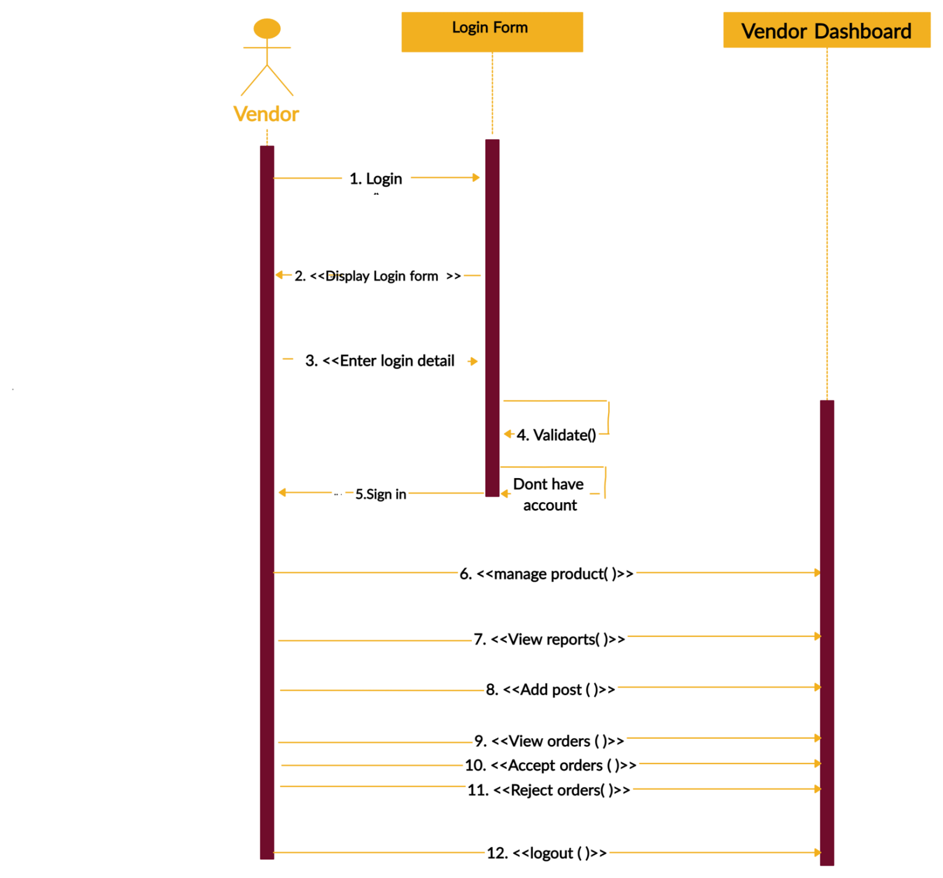

**Figure[1]: Sequence diagram for vendors**

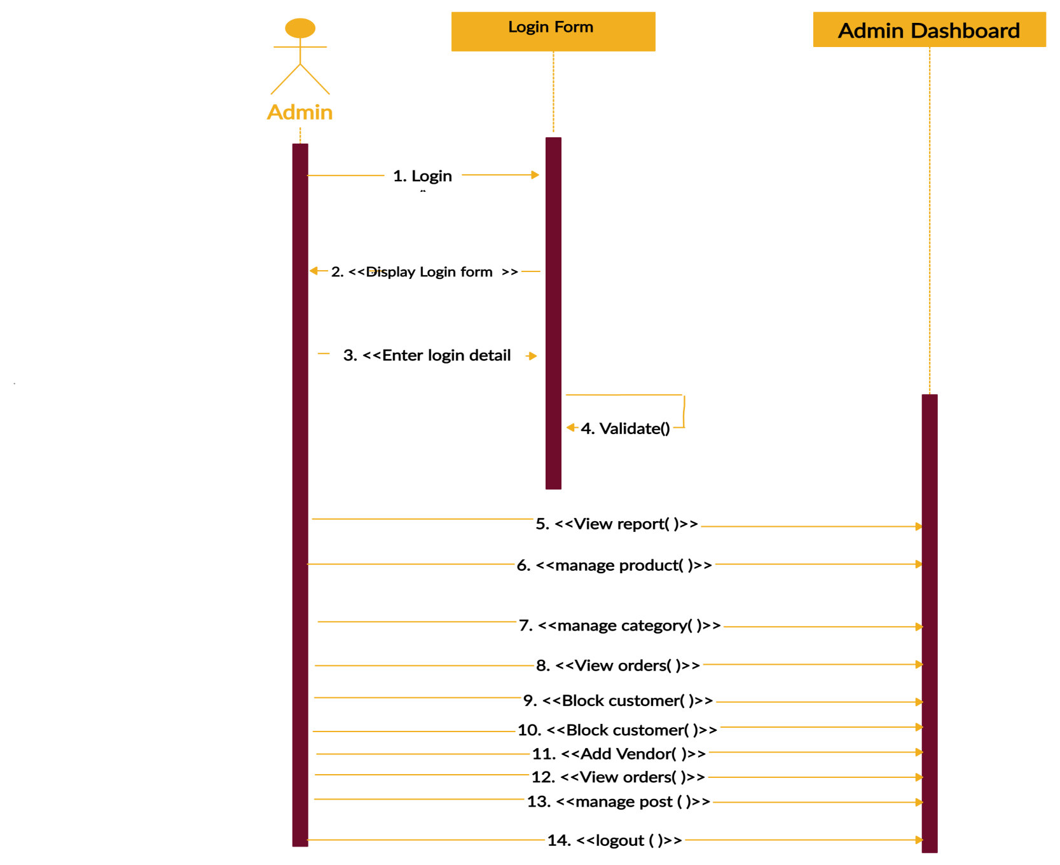

**Figure[2]: Sequence diagram for Admin**

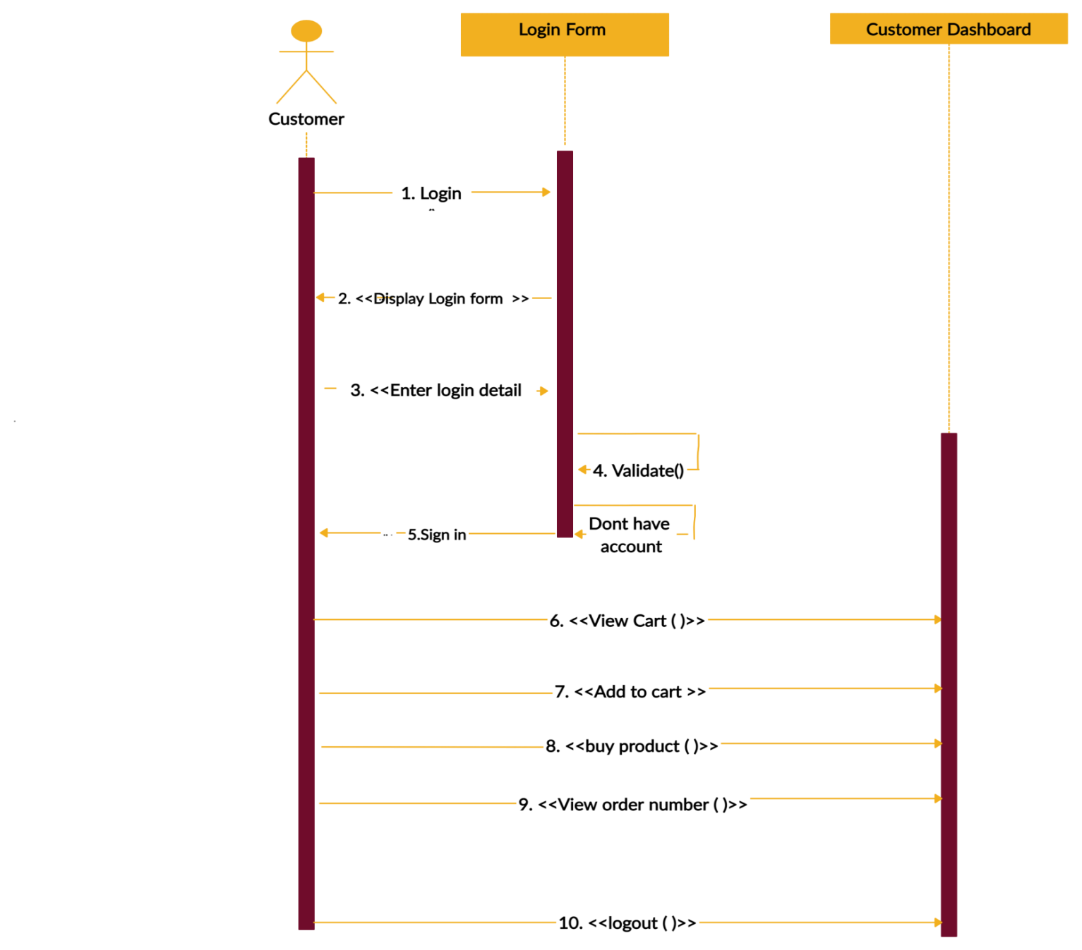

**Figure[3]: Sequence diagram for customer**

# C:\Users\Computer\Downloads\Untitled Document (3).png

**Figure[4]: use case for Admin**

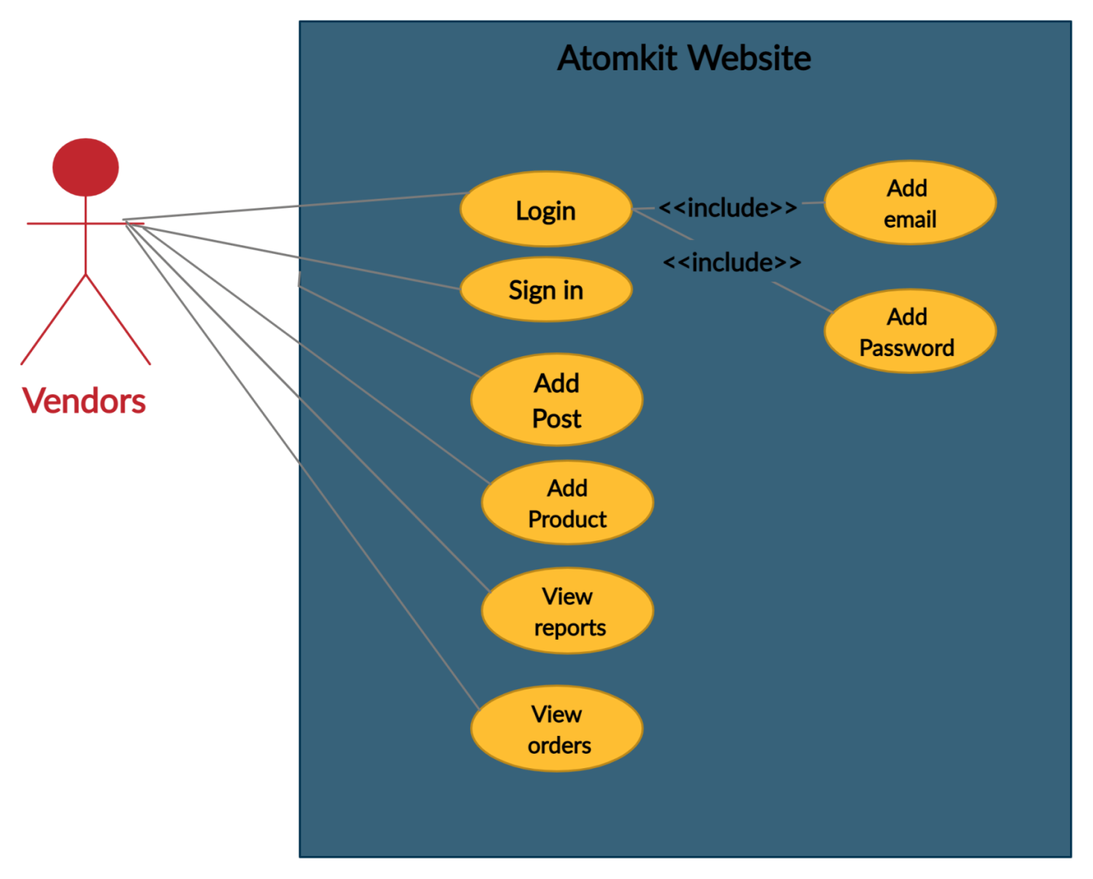

**Figure[5]: use case for vendors**

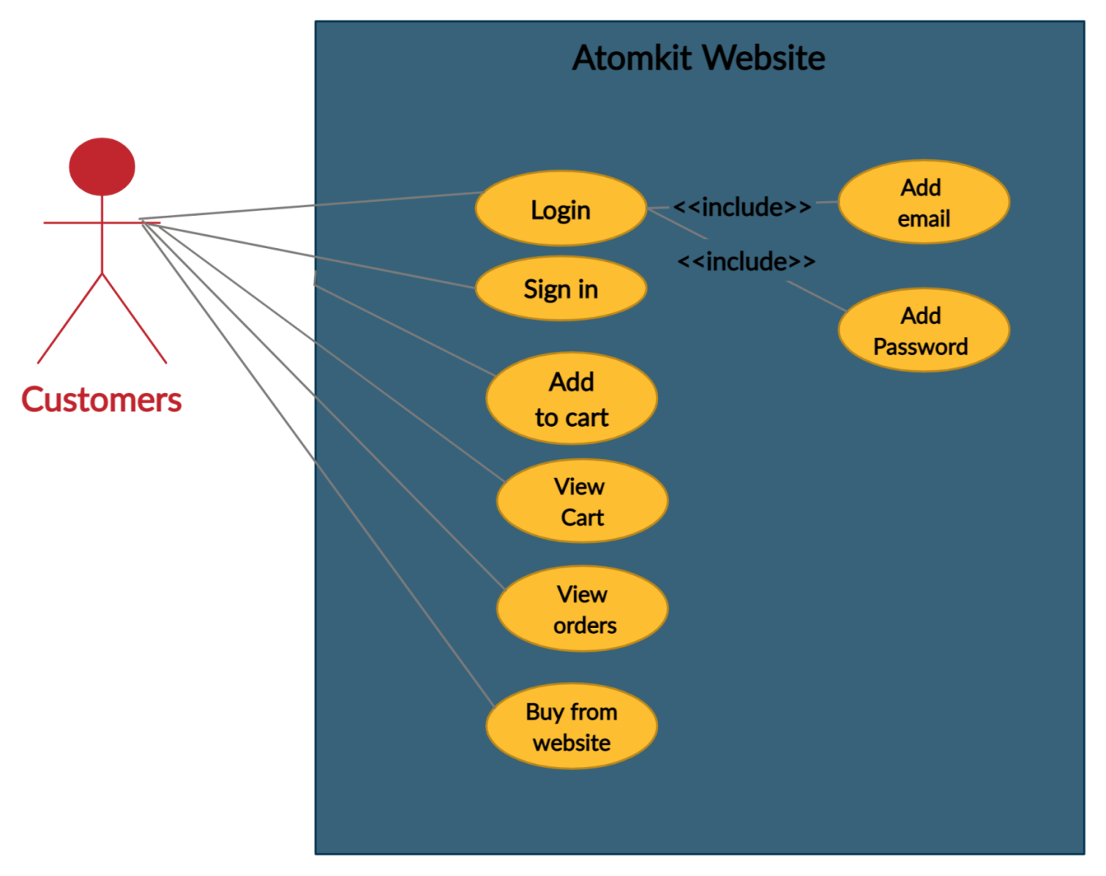

**Figure[6]: use case for customer**

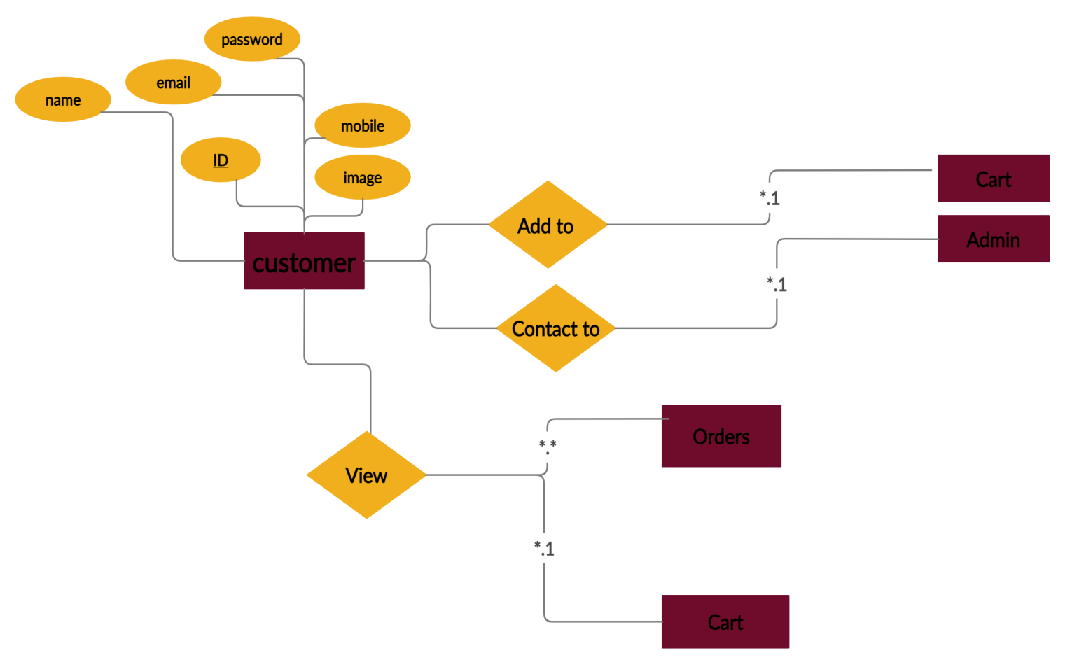

**Figure[7]: ER Diagram for customer**

# C:\Users\Computer\Downloads\Untitled Document (9).png

# Figure[8]: ER Diagram for vendors

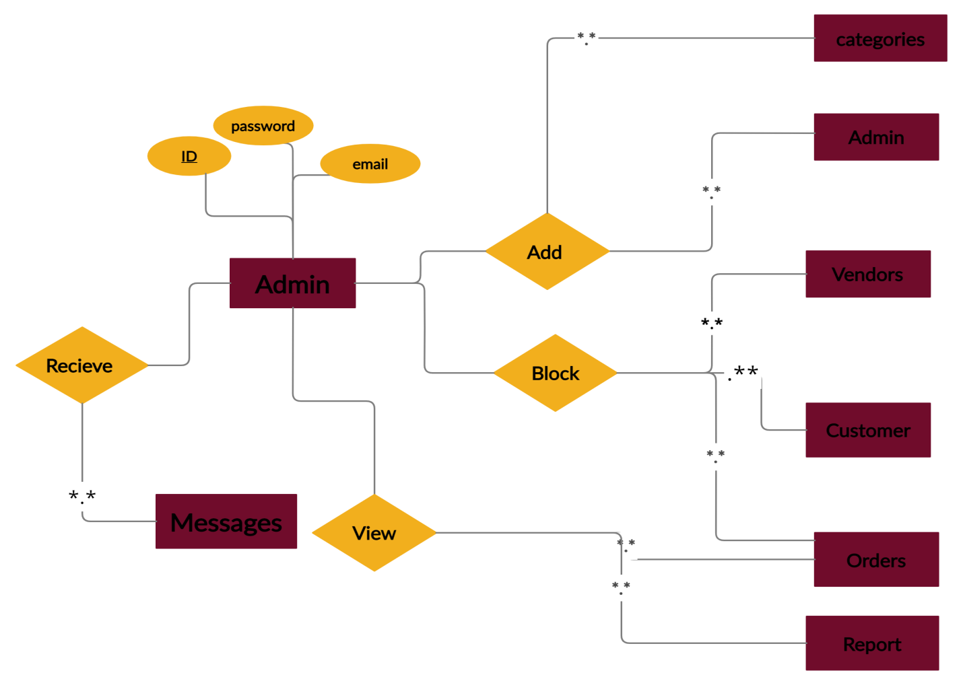

# Figure[9]: ER Diagram for Admins

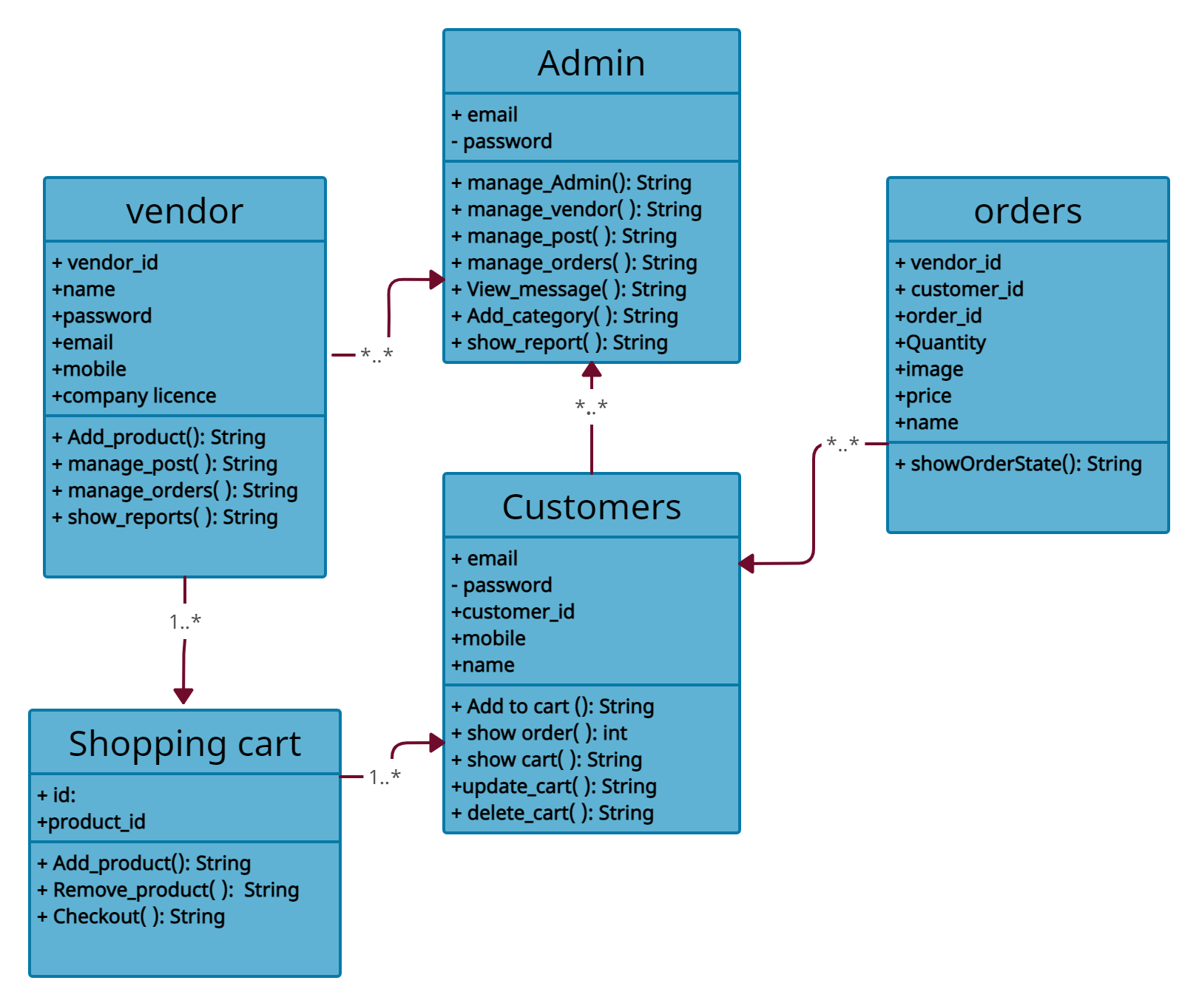

# Figure[9]: Class Diagram for Atomkit

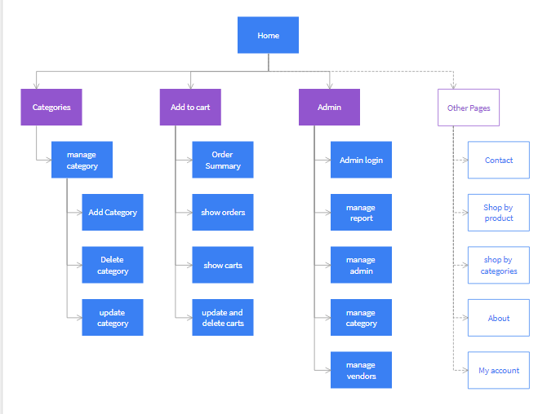

# Figure[10]: Site map for Atomkit

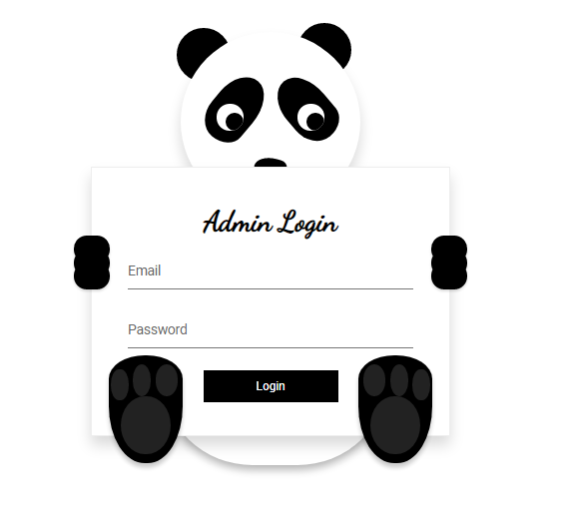

# Figure[11]: Admin login

Admin login to panel by enter correct password and user name.

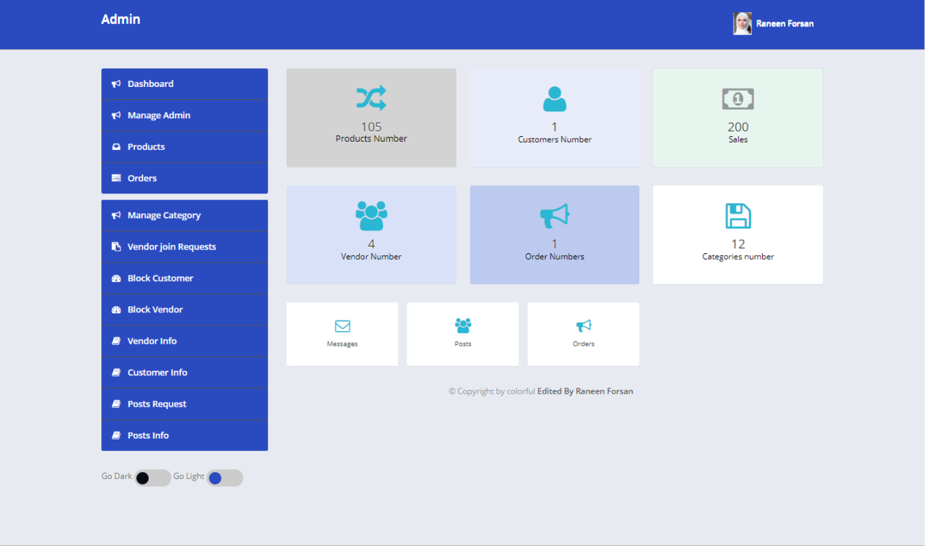

# Figure[12]: Admin Panel

# On this page there are many feature for admin: Admin can know about the sales, customer number, products number, vendor number, order number and the number of category, he can open the post page and accept or reject it, he can open the orders and the message that comes from customer. He can manage category, he can block customer, block vendors , open customer information, open vendor information.

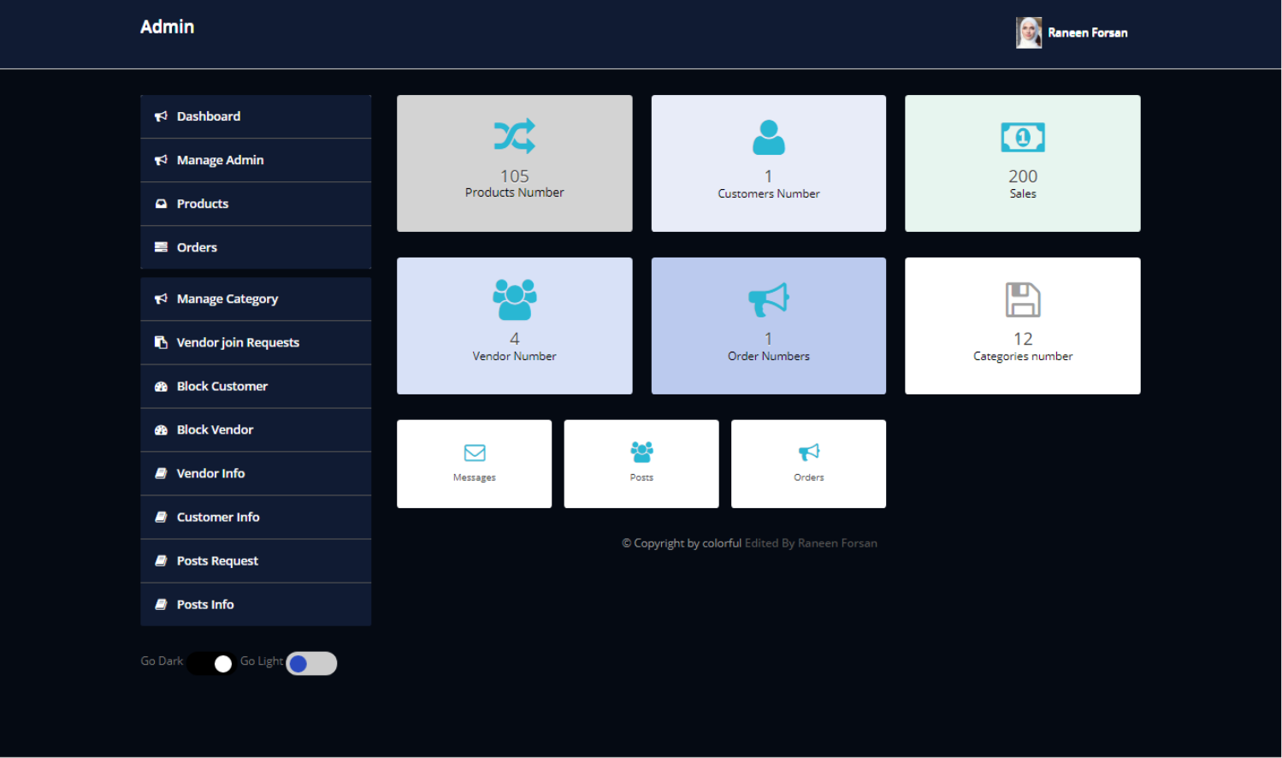

# Figure[13]: Admin Panel on dark mode

If you want admin panel to be in a dark mode you can do it by clicking in go dark button.

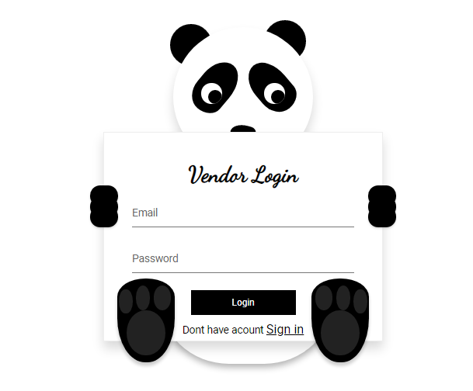

# Figure[14]: Vendor Login

# Vendor will log into panel after enter correct email and password, if he doesn't have account, he should sign in system by click into link sign in .

# C:\Users\Computer\Downloads\2021-02-05-19-28-localhost.png

# 

# Figure[14]: Vendor panel

Vendor will log into panel after log into panel he can add product, show orders and manage it, manage post , vendor can know about how many product uploaded by him and about the sales, about how many customer that deal with system and how many orders in system.

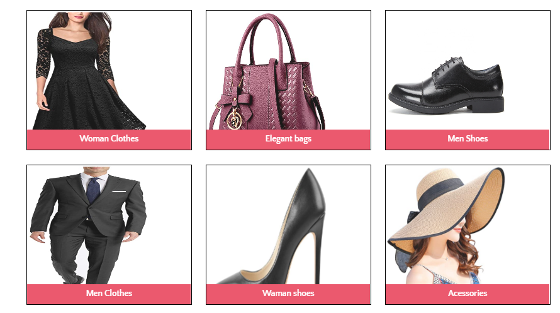

**Figure[15] :Category website**

# On public website, you can see the category and choose any category on each category you can see the products related to category.

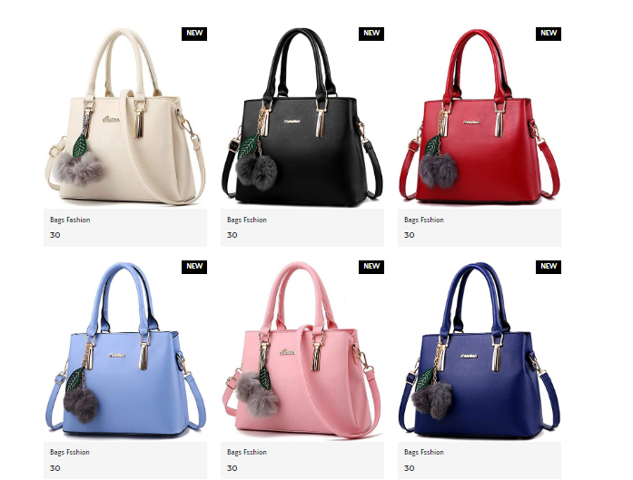

**Figure[16] :Product page**

If you click on bags category you will show the product of bag category.

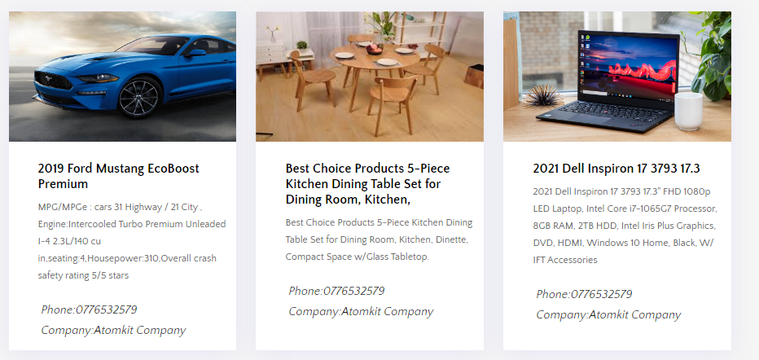

**Figure[16] :Category website**

You can read about the post from the website that uploaded by vendor .

# 

**Figure[16] :Cart**

When you add product to cart you can show the product added and then you should click on checkout and login to view your order number.

# Results and discussion

As I result, I developed a website for ecommerce for customers who like to buy from ecommerce website and for vendors who likes to sell online and get a huge profit with less cost and effort. I called this website as Automkit website which sell qualified products , the product that Atomkit sell is woman clothes, elegant bags, men shoes, men clothes, woman shoes, Accessories, Furniture, electronics, flats, vehicles, toys, phones. Automkit is a secure website , no vendors know information about other vendor. It is usable and friendly.

# Conclusions and recommendations

In my opinion, the results show that many people like to buy from ecommerce website but it is challenging for programmer to develop and design very good, which means ecommerce website should be usable, friendly website. As well as, it's challenging for vendor to sell a very high quality products which play a key role on the success of project .

# References

[1] <https://app.creately.com/diagram/>

[2] <https://www.youtube.com/watch?v=CZTb1qDgqco>

[3]<https://www.w3schools.com/>

[4] [https://www.thinkwithgoogle.com/intl/en-145/coronavirus-change-search-behaviour- trends/?gclid=CjwKCAiA9vOABhBfEiwATCi7GKl7cZFzWzRbDpF_fP1rzyj5GEpBlIgF-IqLsCjxQplNyxoESGNKbxoCGs8QAvD_BwE](https://www.thinkwithgoogle.com/intl/en-145/coronavirus-change-search-behaviour-%20%20trends/?gclid=CjwKCAiA9vOABhBfEiwATCi7GKl7cZFzWzRbDpF_fP1rzyj5GEpBlIgF-IqLsCjxQplNyxoESGNKbxoCGs8QAvD_BwE)